**S A W S**

**Rip Saw vs Crosscut Saw**

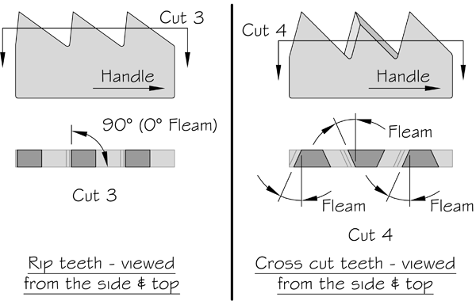

**Common features**

Larger saws used for forestry and logging work include both one-man and [two-man saws](http://en.wikipedia.org/wiki/Two-man_saw), and both **bucking** and **felling** saws.

***A***[***bucking***](http://en.wikipedia.org/wiki/Log_bucking) ***saw*** generally has a straighter back and less of a pronounced curve on its cutting surface. Since bucking saws are more often used on trees that are already downed, the greater stiffness and weight aids swift cutting, and allows two-man saws to also be used by one person, pushing as well as pulling.

***A felling saw*** is generally less stiff than a bucking saw and the backside, as well as the cutting side, is usually curved inward. Felling saws are more often used to cut down standing trees, so the thinner, lighter design is easier to use without gravity holding the blade against the cut. The concave back of the saw makes it easier to place wedges, preventing the [kerf](http://en.wiktionary.org/wiki/kerf) from closing on the saw.

Crosscut saws also include smaller [hand saws](http://en.wikipedia.org/wiki/Hand_saw) used in carpentry.

**Common tooth patterns found on Crosscut saws.**

[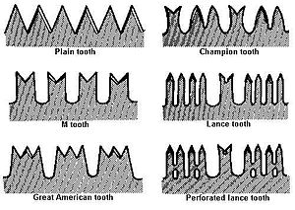](http://en.wikipedia.org/wiki/File:Crosscut_saw_tooth_patterns.jpg)

A **Lance** or **Perforated Lance** tooth is the preferred choice for softwoods like Douglas Fir, hemlocks, spruce, pine, etc.

**How crosscut saws cut**

A saw functions like a series of knives (teeth) making simultaneous parallel cuts and releasing the wood between them.

**Cutter Teeth**

All saws, regardless of the tooth pattern, are made up of two rows of cutting edges. The saw releases wood fibers on each side of the kerf as it passes through a log (figure 4-6).Cutters work best in brittle, seasoned wood. The weakened fiber is easily removed.

**Rakers**

Wet or green wood is hard to remove from the kerf because itis resilient. Even when the fiber is dislodged, it clogs a saw’s cutter teeth.

A special kind of tooth, the raker, allows the cutter teeth to work more effectively with less effort. Even though the rakers do not sever fiber, they do perform the other two functions of saw teeth: breaking loose the cut fiber and removing it from the log.

Rakers remove material whether the saw is being pushed or pulled. As the saw is pulled toward the operator, the cutters along the saw's surface score the wood to the left and right of the width of the blade, cutting a channel downward into the wood. Many saw tooth patterns have 4 cutters; each cutter that cuts to the left of the blade is paired with another that cuts to the right of the blade.

After the cutters there is generally a raker followed by a gullet. A raker is what does the actual removal of the wood that is being cut. The raker follows the cutters, scraping the bottom of the [kerf](http://en.wiktionary.org/wiki/kerf). As the raker scrapes the bottom of the kerf, the wood is peeled back and stored in the gullet which follows the raker.

As the saw is drawn out of the kerf, the wood that has accumulated in the gullets is allowed to fall out onto the ground. A way to determine whether a saw is working well is to examine the *noodle* shaped strings of wood that are scraped out of the kerf; the presence of fairly long strings indicate that the side cutters are doing their job and that the raker is slicing out the wood cleanly.

**Gullets**

Wood fiber that has been severed must be stored by the saw while it is moved through the kerf and out of the cut. This storage area (the largest space between cutters or groups of cutters)

is called a gullet.The gullet must be large enough to store all the shavings until the gullet clears the log and the shavings fall free. The gullets (figure 4-7) determine the length of saw to use for a given application. Example: A gullet in the middle of a 3-footlog must travel 11

ADDITIONAL INFO:

<http://www.bchmt.org/esbch/Cross%20Cut%20Saw.pdf>