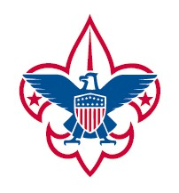 | Troop 233  Personal Camping Gear
If the weather is forecast to be either (i) damp/wet and below 60 degrees or (ii) below 55, bring the Cold Weather Essentials. On all other camping trips, bring the Warm Weather Essentials.
Required for Every Camping Trip
- Scout Handbook
- Sufficient Water (at least two liters of water)
- Sleeping Equipment:
  - Sleeping Bag
  - Thin Sleeping Pad
  - Pajamas
- Waterproof Boots & two pairs of WOOL socks
- Class A Uniform and Class B Tee Shirt
- Tent with ground cloth and adequate stakes (1 tent per 2+ Scouts)
- Flashlight & Batteries (check to make sure it works)
- Mess Kit (bowl, spork, cup)
- Small Personal First Aid
- Toothbrush/Tooth Paste & Personal Medications
Cold Weather Essentials | Warm Weather Essentials
- One pair of long nylon pants (NO DENIM)  - Two long sleeve shirts (not cotton)  - Long underwear tops and bottoms  - Warm ski cap  - Mittens/gloves  - warm sweater or fleece top  - Insulated winter coat (if really cold); nylon waterproof shell if not really cold | - One pair of short pants,  - One pair of nylon long pants (perhaps bottoms unzip to convert into shorts)  - Warm Ski Cap to sleep in  - One short-sleeve shirt  - One thin long-sleeve shirt  - warm sweater or fleece top  - Baseball/sun hat

